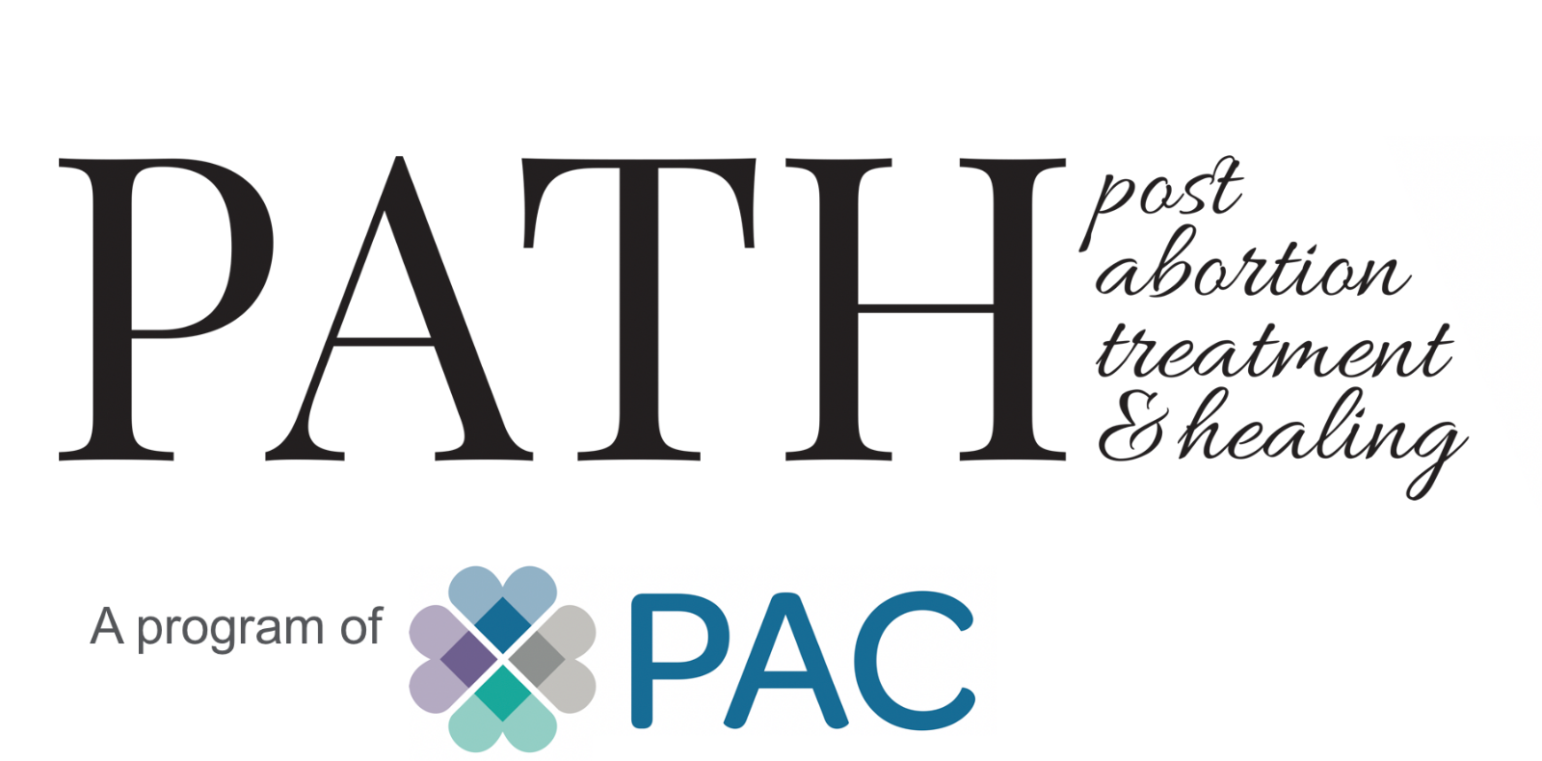
Client Intake Form

The purpose of this questionnaire is twofold. First, we need some background information on you to help us understand how we can best help you. Secondly, answering these questions will begin an important process of remembering for you. The questionnaire will be fairly difficult the longer it has been since your abortion(s). Most women and men who have had an abortion experience would rather “forget” the details. Therefore, don’t try to finish it all in one sitting.

Today’s Date: _____________ Date of birth: ______________ Marital Status: _______________

Name: ____________________________________________________________________________

Address: __________________________________________________________________________

City: _________________________________________ State: ______ Zip: ________________

Phone: _____________________________________________ Type: cell home work

Email: _____________________________________________ OK to contact you? Yes ___ No ___

Children’s Names Age Sex With whom do they live?

__________________________________________________________________________________
__________________________________________________________________________________
__________________________________________________________________________________
__________________________________________________________________________________
__________________________________________________________________________________
Highest grade completed: _______________________ College degree: _______________________

Ethnicity (circle): Caucasian Black Asian Hispanic Other

Give an outline of your religious training as a child: ________________________________________
__________________________________________________________________________________
__________________________________________________________________________________
__________________________________________________________________________________

Are you presently affiliated with any religious organization? ________________________________
__________________________________________________________________________________

While you were growing up, did any of your family have any of the following problems? (circle)

Alcohol Grandparent Parent Sibling
Drugs Grandparent Parent Sibling
Legal Grandparent Parent Sibling
Emotional illness Grandparent Parent Sibling
Medical illness Grandparent Parent Sibling
Financial Grandparent Parent Sibling
NOTE: If you had more than one, please complete for each abortion

Approximate date of abortion: ___________________ Your age at the time: _________________
How many weeks along were you? _______
Type of abortion? Surgical _____ Pill (RU486) ______ Other ______
Where did you have your abortion? Clinic _____ Dr’s Office _____ Home ____ Other ____

Approximate date of abortion: ___________________ Your age at the time: _________________
How many weeks along were you? __________
Type of abortion? Surgical _____ Pill (RU486) ______ Other ______
Where did you have your abortion? Clinic _____ Dr’s Office _____ Home ____ Other ____
Approximate date of abortion: ___________________ Your age at the time: _________________
How many weeks along were you? __________
Type of abortion? Surgical _____ Pill (RU486) ______ Other ______
Where did you have your abortion? Clinic _____ Dr’s Office _____ Home ____ Other ____
Approximate date of abortion: ___________________ Your age at the time: _________________
How many weeks along were you? __________
Type of abortion? Surgical _____ Pill (RU486) ______ Other ______
Where did you have your abortion? Clinic _____ Dr’s Office _____ Home ____ Other ____
Approximate date of abortion: ___________________ Your age at the time: _________________
How many weeks along were you? __________
Type of abortion? Surgical _____ Pill (RU486) ______ Other ______
Where did you have your abortion? Clinic _____ Dr’s Office _____ Home ____ Other ____

Have you had any miscarriages? Yes _____ No _____

If yes, date(s) of miscarriage(s): _______________________________________________________
__________________________________________________________________________________

Check any of the following that applied to you right after your abortion and any that you have experienced in the past six months:
Symptom | Right after abortion | past 6 months
Guilt | _____________ | _____________
Emotionally “numb” | _____________ | _____________
Dreams/Nightmares/Triggers | _____________ | _____________
Change in Relationships | _____________ | _____________
Feelings of inferiority | _____________ | _____________
Dizziness/Fainting | _____________ | _____________
Sleep Disturbances | _____________ | _____________
Can’t make friends | _____________ | _____________
Sexual problems | _____________ | _____________
Preoccupation with abortion date | _____________ | _____________
Preoccupation with due date | _____________ | _____________
Relief | _____________ | _____________
Depressed | _____________ | _____________
Sadness | _____________ | _____________
Anxiety / Inability to Relax | _____________ | _____________
Suicidal thoughts | _____________ | _____________
Sedatives | _____________ | _____________
Alcohol/Drugs | _____________ | _____________
Loneliness | _____________ | _____________
Sense of Loss | _____________ | _____________
Infertility | _____________ | _____________
Crying Spells | _____________ | _____________
Regret | _____________ | _____________
Helplessness | _____________ | _____________
Angry / Bitterness / Rage | _____________ | _____________
Panic Feelings | _____________ | _____________
Emotional Eating / Eating Disorder | _____________ | _____________
Marital Stress | _____________ | _____________
Fatigue | _____________ | _____________
Shame | _____________ | _____________
Inability to Forgive Others / Self | _____________ | _____________
Fear of not being forgiven by God | _____________ | _____________

Have you ever sought counseling for the pain connected with your abortion? _____________________
__________________________________________________________________________________
__________________________________________________________________________________

Were you helped? ___________________________________________________________________
__________________________________________________________________________________
__________________________________________________________________________________
__________________________________________________________________________________

What was beneficial in the help you received? ___________________________________________
_________________________________________________________________________________
_________________________________________________________________________________
_________________________________________________________________________________
_________________________________________________________________________________

Have you ever sought any other abortion recovery healing programs? __________________________
__________________________________________________________________________________
__________________________________________________________________________________

If so, what program(s) were they? _____________________________________________________

Were you helped? __________________________________________________________________

What was beneficial in the help you received? ____________________________________________
__________________________________________________________________________________
__________________________________________________________________________________
__________________________________________________________________________________

Have you ever had medication prescribed (e.g. antidepressants) and/or been hospitalized in an effort to control any symptoms? Yes ______ No _______

If “yes”, please give details: __________________________________________________________
__________________________________________________________________________________
__________________________________________________________________________________

Did you feel you were adequately counseled and informed before the abortion? Yes ___ No ___

If not, what do you wish you had had in the way of counseling? (Check all that apply.)
    - more information on fetal development
    - more sensitivity to how I was feeling
    - more information about the abortion procedure
    - more resources on other options (adoption; parenting)
    - (other): ___________________________________________________________________

At the time, who knew about your abortion? __________________________________________________________________________________

At the time, did you feel pressured/coerced into having the abortion? Yes ___ No ____
Please explain ______________________________________________________________________
__________________________________________________________________________________
__________________________________________________________________________________
__________________________________________________________________________________

What do you think would have been a SIGNIFICANT factor in helping you make a decision to keep the pregnancy? (Check all that apply.)

- support from boyfriend/husband/parents/friends
- a pro-life center which offers emotional and practical support for a decision to keep the baby
- knowing more about the abortion procedure
- knowing more about what fetus looked like
- being warned about possible emotional after-effects
- resources/information about the adoption process
- (other): ___________________________________________________________________
___________________________________________________________________
___________________________________________________________________

Did your relationship with the male involved in the pregnancy continue after the procedure?
Yes ____ No ____

Describe how the relationship was affected by the abortion: __________________________________
__________________________________________________________________________________
__________________________________________________________________________________
__________________________________________________________________________________
__________________________________________________________________________________

Did you experience any physical complications resulting from the procedure (hemorrhage, infection, high fever, perforated uterus, intense cramping, incomplete abortion, etc)?

Please explain: _____________________________________________________________________
__________________________________________________________________________________
__________________________________________________________________________________

If you are a Christian, do you feel God has forgiven you for this abortion? Yes ____ No ____

Do you feel you have forgiven yourself? _________Yes _________ No

State, in your own words, why you want to participate in PATH’s abortion recovery healing program(s)?

__________________________________________________________________________________
__________________________________________________________________________________
__________________________________________________________________________________
__________________________________________________________________________________
__________________________________________________________________________________

How did you hear about PATH’s abortion recovery healing program?

- Website
- Church Bulletin
- Priest or Pastor
- Friend
- Other _____________________________________________________________

Thank you for taking the time to fill this out!
May God bless and keep you!

